**Contents**

**User Guide**

1. **Quick Start**
2. **Understanding User Interface**
   1. **List Pane**
      1. **Tasks**
      2. **Overdue Tasks**
   2. **Message bar**
   3. **Command bar**
3. **Feature Details**
   1. **Add tasks**
      1. **Add untimed tasks**
      2. **Add deadline tasks**
      3. **Add event tasks**
   2. **Delete tasks**
   3. **Update tasks**
      1. **Update tasks other than reserved**
      2. **Update reserved tasks**
   4. **Postpone tasks**
   5. **Search tasks**
   6. **Reserve Tasks**
   7. **Confirm time slot**
   8. **Mark as done/undone**
   9. **Change storage location**
   10. **Undo/Redo**
   11. **Help screen**
   12. **Exit**
4. **Cheat Sheet**

**Developer’s Manual**

1. **Architecture**
2. **GUI Component**
   1. **App Class**
   2. **GUIController Class**
   3. **AppPage Class**
   4. **Bridge Class**
3. **Logic Component**
   1. **Logic Class**
   2. **ReminderOverdue Class**
4. **Storage Component**
   1. **LogStorage Class**
   2. **Storage Class**
   3. **StorageFilePath Class**
5. **Parser Component**
   1. **InputSuggestion Class**
   2. **JListeeParser Class**
6. **History Component**
   1. **History Class**
7. **Entity Component**
   1. **Command Class**
   2. **Display Class**
   3. **Task Class**
   4. **GlobalLogger Class**
8. **Acknowledgements**

**User Guide**

1. **Quick Start**

**Step 1: Install and configure Java environment on your computer. You can download JDK** [here](http://www.oracle.com/technetwork/java/javase/downloads/index.html)**.**

**Step 2: Download J.Listee.jar from** [GitHub](https://github.com/cs2103jan2016-t15-2j/main)**.**

**Step 3: Double-click on the jar file to run the application.**

**Step 4: Try to type the following commands in the command box and see what’s happening:**

**add my first task @icube #cs2103 from today 4pm to 6pm (enter)**

**update 1 updated first task (enter)**

**done 1 (enter)**

**Step 5: Now you can add more tasks and get ready to enjoy your life in order!**

1. **Understanding the User Interface**
   1. 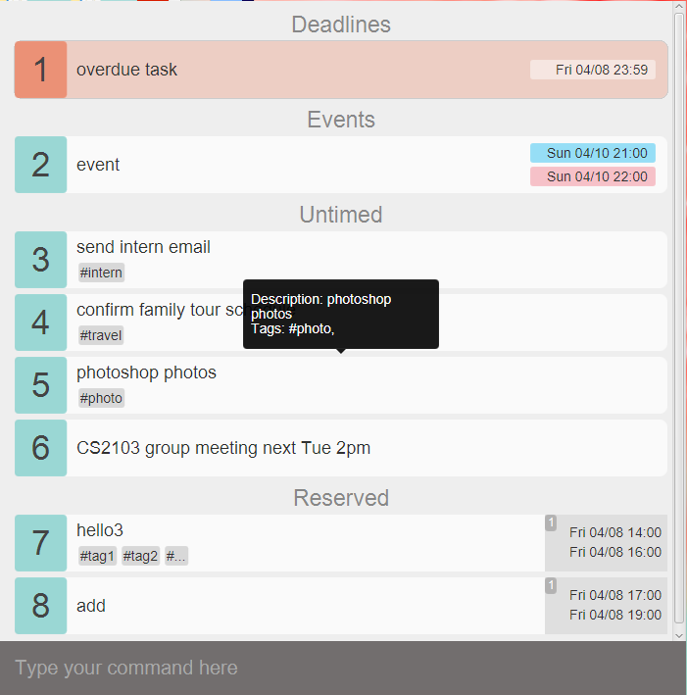**List Pane**

**The first part is the list pane which displays lists of tasks.**

**On startup, J.Listee will show you overdue tasks, today’s tasks, untimed tasks and reserved tasks, automatically ordered by time within each group.**

* + 1. 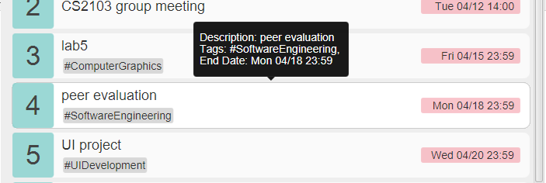**Tasks**

**The list pane contains blocks of tasks.**

**You can use arrow keys (↑ and ↓) or click to focus a specific task when the command bar is not focused. The focused task will be highlighted and a tooltip containing all of the task’s information will appear. The focused task can then be managed using keyboard shortcut, which will be detailed in Feature Details.**

* + 1. **Overdue tasks**

**Overdue tasks will be colored in red to remind you. And they are constantly synchronized by J.Listee, which means as soon as a task becomes overdue, you will immediately be reminded!**

* 1. 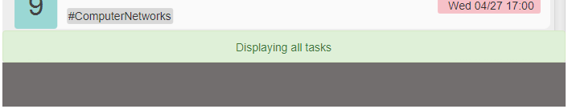**Message bar**

**Every time you make some operations, the message bar containing feedback messages will be automatically triggered and disappear after a while.**

* 1. 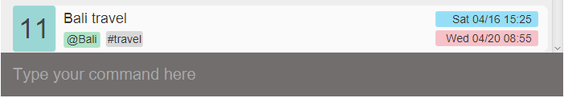**Command Bar**

**The command bar is where you type your command and tell J.Listee what to do next.**

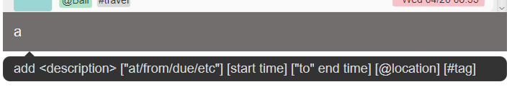**You can use arrow keys (↑ and ↓) to retrieve previous or later commands you have entered when the command bar is focused. Usually when an operation is made, the focus will be on some tasks in the list pane. Then you can press space bar to focus command bar again and type your next command.**

**When you are typing in the command bar, command suggestion will be shown. So follow them if you forget the command format!**

1. **Feature Details**
   1. **Add tasks**

**This command enables you to add a task into J.Listee. The task will be assigned a task number when listed to you. After adding the task, the list of all tasks will automatically be displayed in the current page.**

* + 1. **Add untimed tasks**

|  |
| --- |
| ****add wash clothes some time @home #laundry**** |

**Format:**

**<add> [description] [@location] [#tags**

**Must-have arguments:**

**Task description**

**Optional arguments:**

**location, tags (tags cannot contain whitespace)**

* + 1. **Add deadline tasks**

|  |
| --- |
| ****add watch BigBang Theory this Monday @mac-common**** |

**Format:**

**<add> [description] [<preposition> time] [@location] [#tags**

**Must-have arguments:**

**Task description, deadline time**

**Optional arguments:**

**location, tags (tags cannot contain whitespace)**

* + 1. **Add event tasks**

|  |
| --- |
| ****add Bali Travel from 4/16 to 4/20 @Bali #travel**** |

**Format:**

**<add> [description] [<from> start time <to>end time] [*@*location] [#tags**

**Must-have arguments:**

**Task description, start time, end time**

**Optional arguments:**

**location, tags (tags cannot contain whitespace)**

* 1. **Delete tasks**

**This command enables you to delete existing tasks from J.Listee.**

|  |
| --- |
| ****delete 1-3, 5**** |

**Which means to delete task 1, 2, 3 and 5**

**Format:**

**<delete> <starting task number - ending task number>**

**<delete> <tasknumber, tasknumber,tasknumber>**

**Must-have arguments:**

**at least one task number**

**Optional arguments:**

**more task number separated by English comma or linked by minus**

**Shortcut:**

**Select the specific task and press Backspace or Delete, the task will be deleted.**

* 1. **Update tasks**

**This command enables you to update an existing task in J.Listee.**

**3.3.1 Update tasks other than reserved**

|  |
| --- |
| ****update 2 more work +end tonight 2359**** |

**Which means to update the 2nd task’s description to “more work” and add end time “tonight 23:59”**

**Format:**

**<update> <task number> [+ OR - <timegroup> time] [task description] [@location] OR [-@] [#hashtags][-#deletehashtags]**

**Must-have arguments:**

**a task number indicating the specific task**

**Optional arguments:**

**new task description, removing start time, new start time, new end time, removing existing location OR new location, removing specific tags, new tags**

**3.3.2 Update reserved tasks**

|  |
| --- |
| ****update 3 2 +start today 4pm**** |

**Which means to update the 3rd task, the 2nd time slot’s start time to “today 4pm”**

**Format:**

**<update> <task number > [<reservation index> < [-] OR [+] timegroup [time]> [task description] [@location] OR [-@] [#hashtags][-#deletehashtags]**

**Must-have arguments:**

**a task number indicating the specific task, a reservation index indicating the specific time slot reserved**

**Optional arguments:**

**new task description, new start time, new end time, removing existing location OR new location, removing specific tags, new tags**

* 1. **Postpone tasks**

**This command enables you to postpone the deadline of an existing task for some minutes, hours, days, months, years.**

|  |
| --- |
| ****postpone 3 3years 2months 8days**** |

**Format:**

**<postpone> <task number> <time>**

**Must-have arguments:**

**a task number indicating a specific task, time**

**Shortcut:**

**Select the specific task and press p, the deadline of the task will be postponed for 1 day.**

* 1. **Search tasks**

**This command enables you to see specific tasks in a time period or with some specific information.**

|  |
| --- |
| ****show /today @school assignment**** |

**Which means to show today’s task at school with the keyword assignment**

**Format:**

**<show> [task description] [/taskgroup] [<preposition> time] [@location] [#hashtags]**

**Must-have arguments:**

**some filter**

* 1. **Reserve tasks**

**This command enables you to reserve multiple time slots for later use.**

|  |
| --- |
| ****reserve meet friends from thurs 4pm to Thursday 6pm or friday****  ****4pm to 6pm #dinner**** |

**Which means to the reserved “meet friends” task will have 2 timeslots, one from Thusday 4pm to 6pm, the other from Friday 4pm to 6pm**

**Format:**

**reserve <task description> [<from> start time <to> end time] [and/or] [<from> start time <to> end time] [@location] [#hashtags]**

**Must-have arguments:**

**Task description and at least one timeslot**

**Optional arguments:**

**more timeslots linked by and/or**

* 1. **Confirm timeslot**

**This command enables you to confirm one of the time slots you have reserved.**

|  |
| --- |
| ****confirm 2 3**** |

**Which means to confirm the 3rd reserved timeslot of the 2nd task**

**Format:**

**<confirm> <task number> <reservation index>**

**Must-have arguments:**

**a task number indicating the specific task and the index of a timeslot reserved**

**Shortcut:**

**Select the specific task and press the number key, and the corresponding timeslot of the task will be confirmed.**

* 1. **Mark as done/undone**

**This command enables you to mark existing tasks as done/undone. The completed tasks will then disappear from the current page. You can type “show /done” to see the tasks just marked as done.**

|  |
| --- |
| ****undone 1-3,5**** |

**Which means to mark 1, 2, 3, 5 as undone (the tasks must be completed at the first place)**

**Format:**

**<done> <starting task number - ending task number>**

**<done> <tasknumber, tasknumber, tasknumber>**

**Must-have arguments:**

**at least one task number**

**Optional arguments:**

**more task number separated by English comma or linked by minus**

**Shortcut:**

**Select the specific task and press d, if the task is completed, it will be marked as undone, otherwise it’ll be marked as done.**

* 1. **Change storage location**

**This command enables you to change the storage location to the folder you want. After entering this command, a folder choosing window will pop up, and you can choose the folder you want to put the file in.**

|  |
| --- |
| ****change filepath**** |

**Format:**

**change filepath**

**Shortcut:**

**Press ctrl+f to pop up the folder chooser.**

* 1. **Undo/Redo**

**This command enables you to undo or redo the most recent operation.**

|  |
| --- |
| ****redo**** |

**Format:**

**undo/redo**

**Shortcut:**

**Press ctrl+z to undo last operation; Press ctrl+y to redo last undid operation**

* 1. **Help Screen**

**This command enables you to see help screen.**

|  |
| --- |
| ****help**** |

**Format:**

**help**

**Shortcut:**

**Press ctrl+h to see help screen.**

* 1. **Exit**

**This command enables you to exit from J.Listee.**

|  |
| --- |
| ****exit**** |

**Format:**

**exit or quit**

**Shortcut:**

**Press Escape to exit.**